# MySQL crib sheet

**COMMON DATA TYPES FOR MySQL**

VARCHAR(size) – String with a maximum length of 255 characters

TEXT - String with a maximum length of 65535 characters.

INT(size) – size is number of digits.

FLOAT(size, d) - A small number with a floating decimal point. The number of digits may be specified in the size parameter. The maximum number of digits to the right of the decimal point is specified in the d parameter

DATE - A date. Format: **YYYY-MM-DD** **NOTE** date format

DATETIME - A date and time combination. Format: **YYYY-MM-DD** **HH:MM:SS**

TIME - A time. Format: HH:MM:SS

BOOLEAN

## MySQL COMMANDS

**CREATE TABLE** – Makes a completely new table. Must include the fields, with their datatypes and indicate the primary key. In example table name is ‘students’, with 3 fields.

CREATE TABLE students (

StudentNumber INT(8) PRIMARY KEY,

StudentName VARCHAR(32),

DateOfBirth DATE

)

**INSERT INTO** – Makes a new record of data in the table. The values need to be in the same order as the fields in the table. In example the table name is ‘students’, with just three fields.

INSERT INTO Students

VALUES ('0002','Hermione','1984-10-22')

In this example only 2 of the 3 fields in the table will have data in so this is stated in the first line.

INSERT INTO Students(StudentNumber, StudentName)

VALUES ('0003','Ron')

**UPDATE** – edits an existing record. SET is what you want to change, WHERE decides which row you want to change.

UPDATE Students

SET DateOfBirth='1984-09-22'

WHERE StudentName='Hermione'

**DELETE** – Removes a record from the table. Note if you omit WHERE then ALL records will be deleted from table! In example the table name is ‘Students’.

DELETE FROM Students

WHERE StudentName = 'Hermione'

**SELECT** – Searches a table for specific information.

This example returns all fields from the Student table where the studentname is Hary.

SELECT * FROM Students

WHERE StudentName = 'Harry‘

This example will return the StudentName and DateofBirth of all the records in the Student table where the StudentNumber is greater than 1.

SELECT StudentName, DateOfBirth FROM Students

WHERE StudentNumber > 1

**WHERE OPERATORS:**

Comparison operators: = > < <> >= <=

|  |  |
| --- | --- |
| AND | Itemcode=‘2’ AND ordercode = ‘3’ |
| OR | Itemcode = ‘2’ OR itemcode = ‘4’ |
| NOT | NOT itemcode = ‘4’ |
| IS NULL | Address IS NULL |
| BETWEEN…AND… | Orderdate BETWEEN ‘2013/05/10’ AND ‘2013/06/10’ |
| LIKE | Customername LIKE ‘B%’ |
| IN | Itemcode IN (‘1’, ‘2’, ‘3’) |

**ORDER BY –** to order the records returned. Defaults to ascending.

SELECT * FROM students

WHERE studentnumber > 1

ORDER BY studentname DESC

**MULTIPLE TABLE DATABASE**

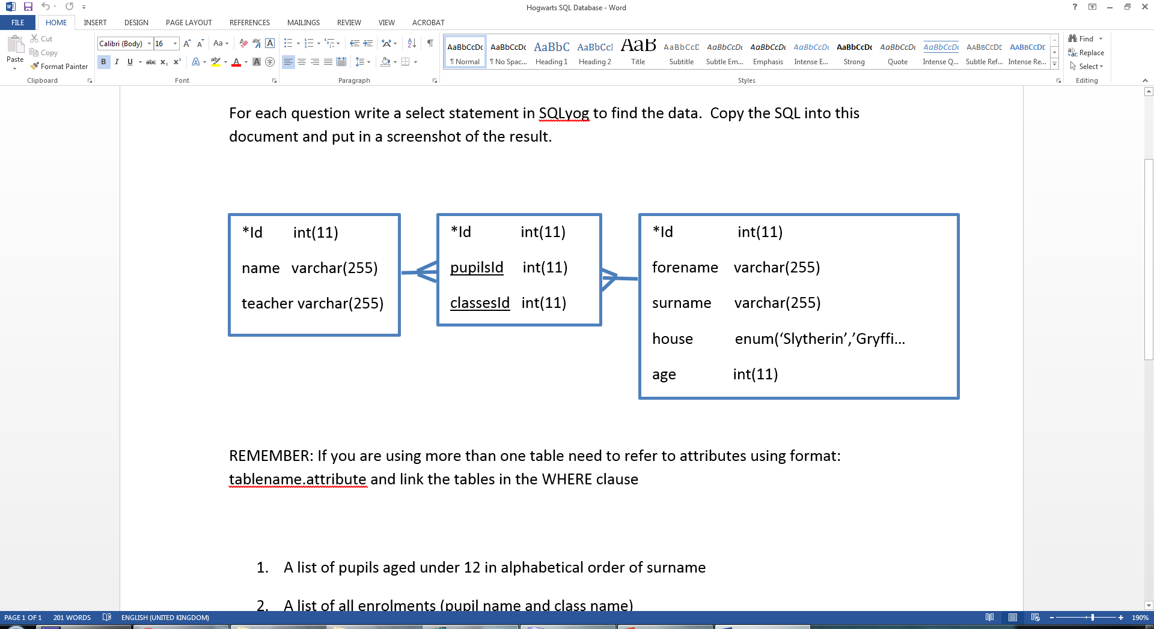

Need to refer to the table name when using attributes in SQL. Also need to put in the link between the tables in the WHERE clause. In the example below the pupils table is linked to the enrolment table via the pupilsID field and the classes table is linked to the enrolment table via the classesID field. The query returns the pupils forename and surname and for all pupils in the potion class.

SELECT pupils.forename, pupils.surname

FROM pupils, classes, enrolment

WHERE classes.Id = enrolment.classesId AND pupils.Id = enrolment.pupilsId AND classes.name = ‘Potions’